**SIF API**

1. **SoapUI:** The steps of creating SIF API using SoapUI :

* Open SoapUI .
* Go To File and select New Soap Project and give the details :

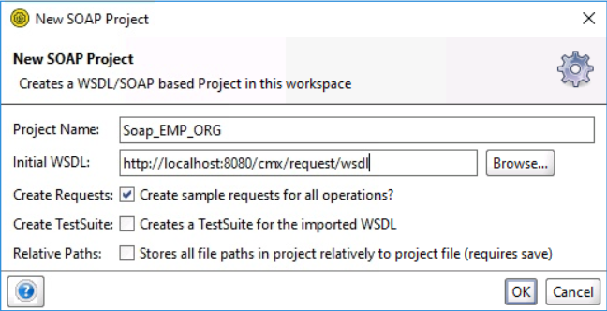

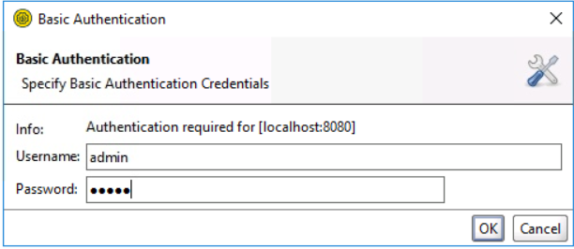

* **Authenticate API :** Click on Authenticate API and give details :

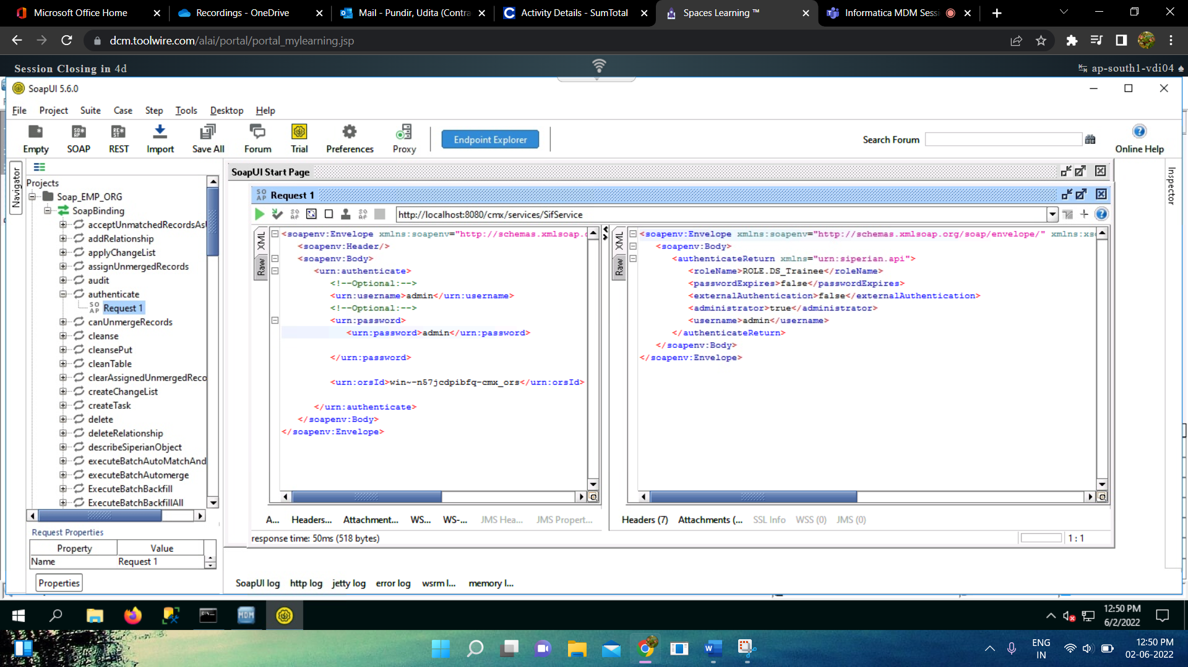

* **GET API :** Click on GET API and give details :

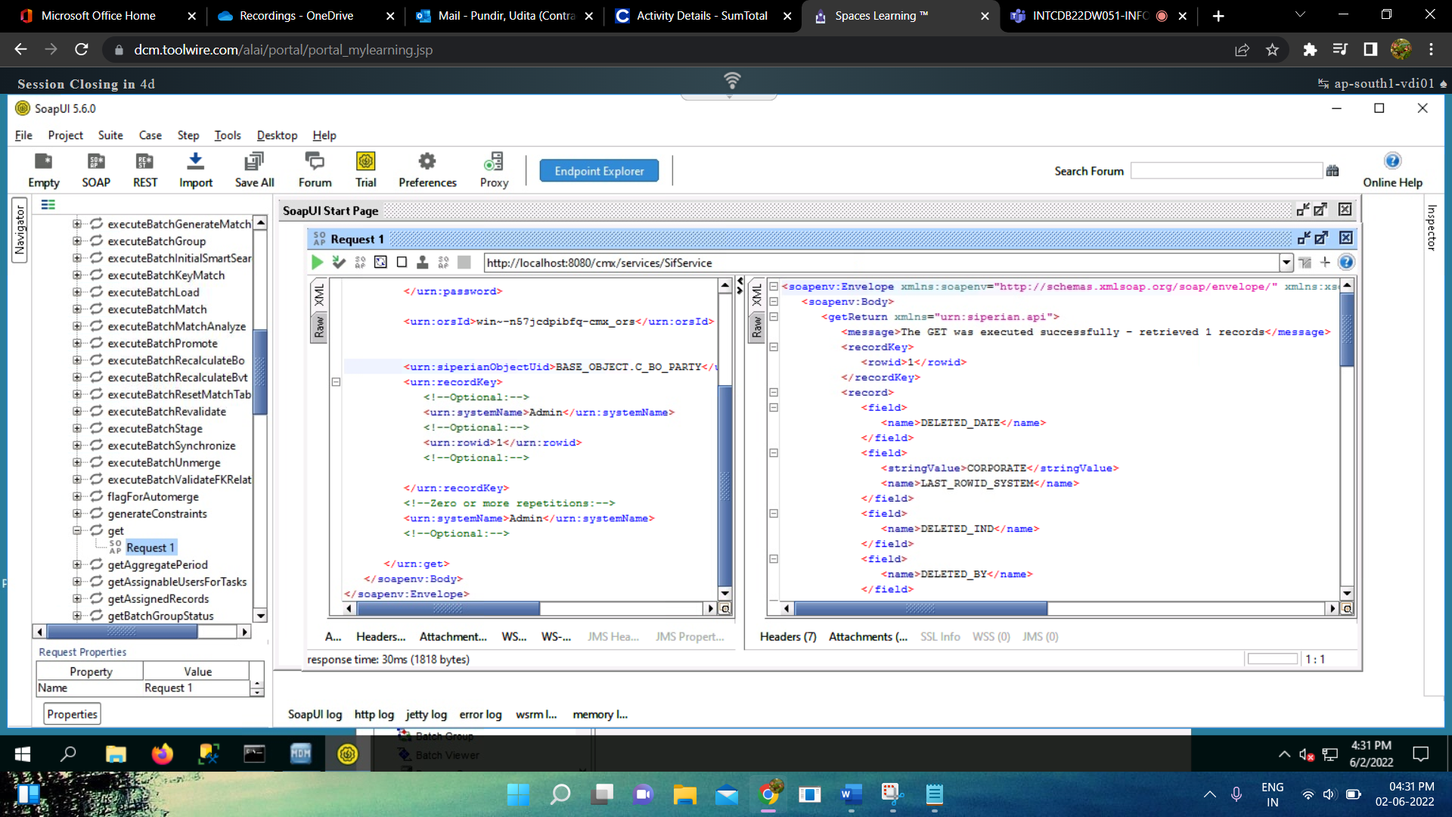

* **PUT API :** Click on PUT API and give details as per the requirements :

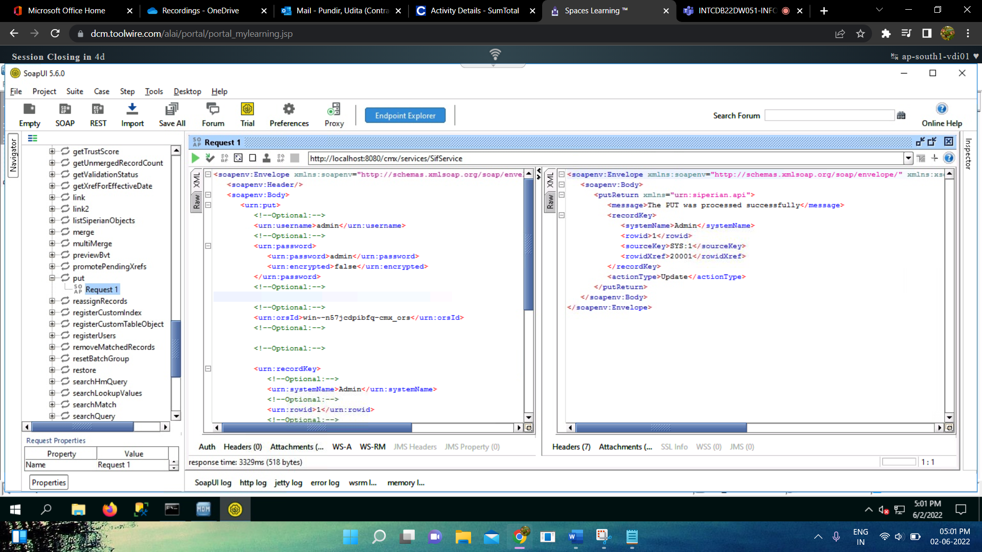

* Like this we can use any API available in the project as per the requirements.